Partner communications document: Healthwatch Norfolk COVID-19 engagement
This document contains relevant communications materials for public and third sector organisations in Norfolk about Healthwatch Norfolk’s (HWN) planned engagement activity around the COVID-19 pandemic. In this document:
- Press release for partner website news streams
- Short-form website copy dedicated web pages
- Links to survey and HWN survey landing page
- Social media graphic

Press release
Share your experience of accessing information, care and support during COVID-19
Healthwatch Norfolk are encouraging people to share their experience of using health and social care services since the outbreak of COVID-19, so that constructive and supportive information can be passed on to service leaders.
The spread of the virus has led to unprecedented changes to the way patients and service users receive care: pharmacies are struggling to keep up with demand for medication; many GP appointments have been postponed or conducted remotely; and strict protocols have been implemented in hospitals and care homes to prevent infection.
Healthwatch Norfolk Chief Executive, Alex Stewart said: “For all of us that use local services it is an unusual time, where we have had to adapt to necessary changes quickly.
“It is crucial we do everything we can to enable staff to do their jobs safely and effectively, but it is equally important that we learn from this experience and that public opinion is listened to.
“Whether you have personally used services or look after someone else that does, this is an opportunity for you to have your say.”
The survey is an opportunity for you to have your say about anything relating to care and support since the outbreak of the virus, but Healthwatch Norfolk are particularly interested in hearing about:
- Quality of local information and advice about coronavirus
- Your experience of urgent and emergency care
- Experience of health and social care routine appointments
- Communication from NHS Trusts, councils and charities
- Managing your mental and physical health at home
- Advice for individuals and families in self-isolation
- Caring for someone in isolation
- Access to dentistry in Norfolk
- Positive experiences and messages of support for health and social care staff
As emergency plans to support Norfolk’s population are rolled out across the county, Healthwatch argue that listening to the public is pivotal to ensuring that the health and wellbeing needs of people are met.
Mr Stewart reinforced Healthwatch’s ability to relay public praise and concerns at this time:
“We have direct links to the public agencies providing front-line services in response to COVID-19, including local authorities, hospitals, GPs, pharmacies and care homes. Our recommendations are taken seriously by service leaders, so every response to our survey will be acknowledged and listened to intently.”
The organisation will provide regular updates to leaders so that real-time feedback can be used to positively impact the way services are being delivered.
To take part in the survey, visit www.healthwatchnorfolk.co.uk/hwn-covid-19-survey/ or contact Healthwatch Norfolk directly on 01953 856029 to share your experience with a member of the team.

Short-form web copy

Share your experience of accessing information, care and support during COVID-19

At Healthwatch Norfolk are working with local councils, hospitals and other service providers to help them understand the needs of their communities in these challenging times.
The organisation is asking people to share their experience of accessing the right information, support and health and social care services by completing our short survey.
Whether you have had a positive or negative experience since the COVID-19 outbreak, it is important that you share your thoughts so that providers know what is working well and what could be improved.
Complete the survey here, or by contacting Healthwatch Norfolk on 01953 856029, where you will be able to complete the survey on the phone with a member of their engagement team.
The survey is an opportunity for you to have your say about anything relating to care and support since the outbreak of the virus, but Healthwatch Norfolk are particularly interested in hearing about:
– Quality of local information and advice about coronavirus
– Your experience of urgent and emergency care
– Experience of health and social care routine appointments
– Communication from NHS trusts, councils and charities
– Managing your mental and physical health at home
– Advice for individuals and families in self-isolation
– Caring for someone in isolation
– Access to dentistry services in Norfolk
– Positive experiences and messages of support for health and social care staff

Survey URL and HWN landing page
Survey: https://www.smartsurvey.co.uk/s/hwncovid19-survey/
HWN landing page: https://healthwatchnorfolk.co.uk/hwn-covid-19-survey/

Social media graphic
Please right click and save the below image to be used on social media platforms

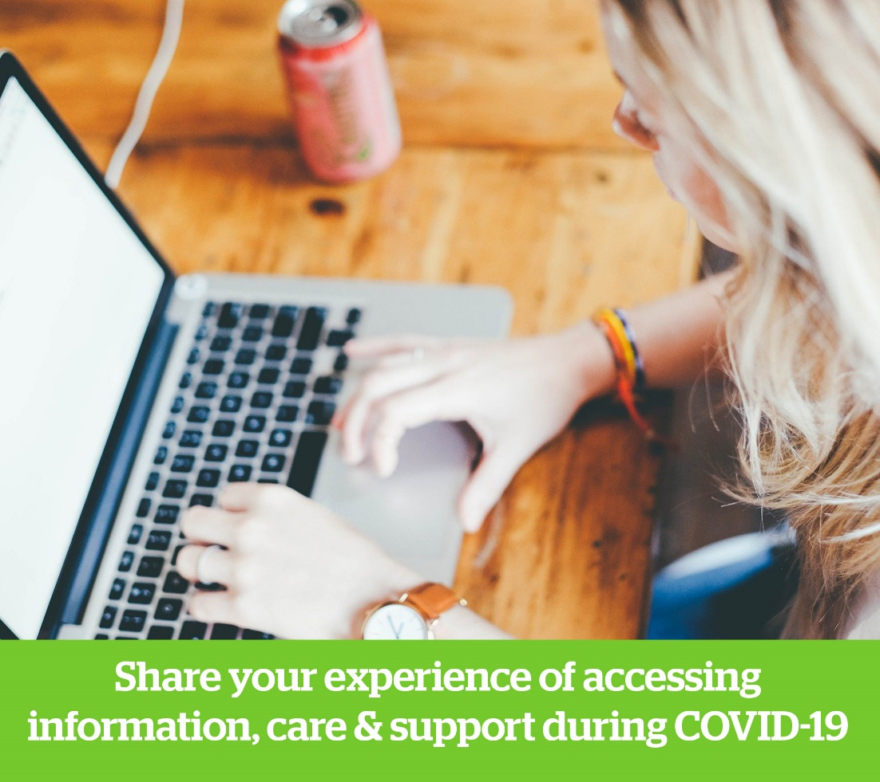

For any enquiries please contact Head of Communications & Engagement, James Skipper:
Email: james.skipper@healthwatchnorfolk.co.uk
Mobile: 07467 145412

